

**Squash**

**Privacy Policy**

**We believe that you should always know what data we collect from you and how we use it, and that you should have significant control over that.**

**We want to empower you to make better decisions about the information you share with us. That is the purpose of this Privacy Policy.**

**You should read this policy in its entirety, but here are some important things we hope you will keep:**

• Squash is public and posts are immediately visible and searchable by anyone worldwide. We also offer you non-public ways to communicate on Squash through Direct Messages. You can also use Squash under a pseudonym if you prefer not to use your name.

• When you use Squash, even if you are just looking at posts, we receive some personal information from you, such as the type of device you are using and your IP address. You can choose to share additional information with us, such as your email address, phone number, address book contacts, and a public profile. We use this information for things like keeping your account secure and showing you more relevant posts, people to follow, events and announcements.

• We provide you with control through your settings to limit what data we collect from you and how we use it, and control things like account security, marketing preferences, apps that can access your account, and contacts from the address book that you climbed in Squash. You can also download the information you've shared on Squash.

• In addition to the information you share with us, we use your posts, content you read or like, and other information to determine what topics you are interested in, your age, languages ​​you speak, and other signs to show content more relevant to you. We provide transparency on this information, and you can modify or correct it at any time.

• If you have any questions about this policy, how we collect or process your personal data, or anything else related to our privacy practices, we would like to hear from you. You can contact us at any time.

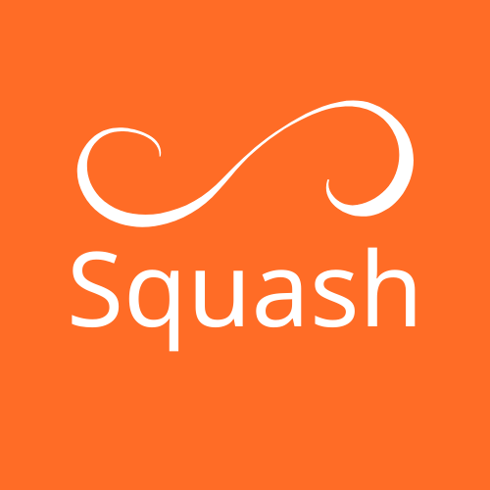

**1 Information you share with us**

We require certain information to provide our services to you. For example, you need to have an account to upload or share content on Squash. When you choose to share the information below with us, we will collect it and use it to operate our services.

* 1. **Basic Account Information**

You don't need to create an account to use some of the features of our services, such as searching and viewing public profiles of Squash users. If you choose to create an account, you will need to provide us with some personal data in order for us to provide our services to you. In Squash, this includes a display name (for example “Club Squash”), a username (for example @ClubSquash), a password, and an email address and phone number. Your display name and username are always public, but you can use your real name or a pseudonym. You can also create and manage multiple accounts in Squash1, for example, to express different parts of your identity.

1 **Its many sides.** Let your imagination run wild. Explore your interests with many different identities.

* 1. **Public Information**

Most activity on Squash is public, including your profile information2, your time zone and language, when you created your account and your posts, and certain information about your posts such as the date, time and version of Squash where you made the post. You can also choose to publish your location in your posts and on your Squash profile. The lists you create, the people you follow and who follow you, and posts you like are also public. If you like, share, respond to or publicly engage with an ad on our services, that advertiser may then learn information about you associated with the ad you engaged with, such as characteristics of the target audience that the ad was supposed to reach. Information published about you by others who use our services may also be public. For example, other people can tag you in a photo3 (if your settings allow it) or mention you in a post.

You are responsible for your posts and other information you provide through our services, and you should think about what to make public, especially key specific information. If you update your public information on Squash by deleting a post or deactivating your account, we will reflect your updated content on Squash for Android.

By publicly sharing content through a post, you are instructing us to disclose that information as widely as possible, including through our APIs, and directing those who access the information through our APIs to do the same. To facilitate the rapid global dissemination of posts to people around the world, we use technologies such as application programming interfaces (APIs) and incorporate them to make some of this information available for websites, applications and for other uses - for example, to display posts in a news site or analyze what people say on Squash. We generally make this content available in limited quantities for free and charge license fees for large-scale access. We have standard terms that govern how this data can be used and a compliance program to enforce these terms. But these individuals and companies are not affiliated with Squash, and their offers may not reflect the updates you make to Squash. For more information on how we make public Squash data available to the world, visit <https://squash.kauavitorio.com> .

2 **Hello World.** Your profile information appears below your photo and username on your profile page.

**3 Be discreet.** Friends want to tag you in a photo? You have luck. If you don't like that sort of thing, you can always change your settings.

* 1. **Contact Information and Address Books**

We use your contact information, such as your email address or phone number, to authenticate your account and keep it - and our services - secure, and to help prevent spam, fraud, and abuse. We also use contact information to enable certain account features (for example, for login verification or Squash via SMS), and to send you information about our services, and to personalize our services, including ads. If you provide us with your phone number, you agree to receive text messages from Squash to that number as your country’s laws allow. Squash also uses your contact information to market to you as your country’s laws allow, and to help others find your account if your settings permit, including through third-party services and client applications. You can use your settings for email and mobile notifications to control notifications you receive from Squash. You can also unsubscribe from a notification by following the instructions contained within the notification.

If you email us, we will keep the content of your message, your email address, and your contact information to respond to your request.

* 1. **Direct Messages and Non-Public Communications**

We provide certain features that let you communicate more privately or control who sees your content. For example, you can use Direct Messages to have non‑public conversations on Squash or protect your posts. When you communicate with others by sending or receiving Direct Messages, we will store and process your communications and information related to them. This includes link scanning for malicious content, link shortening to <https://squash.kauavitorio.com> URLs, detection of spam4, abuse and prohibited images, and use of reported issues. We also use information about whom you have communicated with and when (but not the content of those communications) to better understand the use of our services, to protect the safety and integrity of our platform.

4 **Spam stinks.** We scan your Direct Messages to try and prevent spam for you and our service.

* 1. **How You Control the Information You Share with Us**

**Your Privacy and safety settings let you decide:**

• Whether your posts are publicly available on Squash

• Whether others can tag you in a post

• Whether you will be able to receive Direct Messages from anyone on Squash or just your followers

• Whether others can find you based on your email or phone number

• When and where you may see sensitive content on Squash

• Whether you want to block or mute other Squash accounts

* 1. **Additional Information We Receive About You**

We receive certain information when you use our services or other websites or mobile applications that include our content, and from third parties including advertisers. Like the information you share with us, we use the data below to operate our services.

* 1. **Location Information**

We require information about your signup and current location, which we get from signals such as your IP address or device settings, to securely and reliably set up and maintain your account and to provide our services to you. Subject to your settings, we may collect, use, and store additional information about your location - such as your current precise position or places where you’ve previously used Squash - to operate or personalize our services including with more relevant content like local trends, stories, ads, and suggestions for people to follow. Learn more about Squash’s use of location here, and how to set your Squash location preferences here. Learn more about how to share your location in Periscope broadcasts here.